Command: PLINE

Specify start point: 80,14.5

Current line-width is 0.0000

Specify next point or [Arc/Halfwidth/Length/Undo/Width]: 79,13.5

Specify next point or [Arc/Close/Halfwidth/Length/Undo/Width]: 77.5,13.5

Specify next point or [Arc/Close/Halfwidth/Length/Undo/Width]: 76,12

Specify next point or [Arc/Close/Halfwidth/Length/Undo/Width]: 44,12

Specify next point or [Arc/Close/Halfwidth/Length/Undo/Width]: 44,9

Specify next point or [Arc/Close/Halfwidth/Length/Undo/Width]: 0,9

Specify next point or [Arc/Close/Halfwidth/Length/Undo/Width]: 0,12

Specify next point or [Arc/Close/Halfwidth/Length/Undo/Width]: 2,14

Specify next point or [Arc/Close/Halfwidth/Length/Undo/Width]: 10,14

Specify next point or [Arc/Close/Halfwidth/Length/Undo/Width]: 14,18

Specify next point or [Arc/Close/Halfwidth/Length/Undo/Width]: 31,18

Specify next point or [Arc/Close/Halfwidth/Length/Undo/Width]: 35,14

Specify next point or [Arc/Close/Halfwidth/Length/Undo/Width]: 40,14

Specify next point or [Arc/Close/Halfwidth/Length/Undo/Width]: 40,16.5

Specify next point or [Arc/Close/Halfwidth/Length/Undo/Width]: @32<-300

Specify next point or [Arc/Close/Halfwidth/Length/Undo/Width]: 56,14

Specify next point or [Arc/Close/Halfwidth/Length/Undo/Width]: 61,14

Specify next point or [Arc/Close/Halfwidth/Length/Undo/Width]: 65,18

Specify next point or [Arc/Close/Halfwidth/Length/Undo/Width]: 76,18

Specify next point or [Arc/Close/Halfwidth/Length/Undo/Width]: 79,15

Specify next point or [Arc/Close/Halfwidth/Length/Undo/Width]: 80,15

Specify next point or [Arc/Close/Halfwidth/Length/Undo/Width]: 80,14.5

Specify next point or [Arc/Close/Halfwidth/Length/Undo/Width]: C

Command: REGION

Select objects: 1 found

Select objects:

1 loop extracted.

1 Region created.

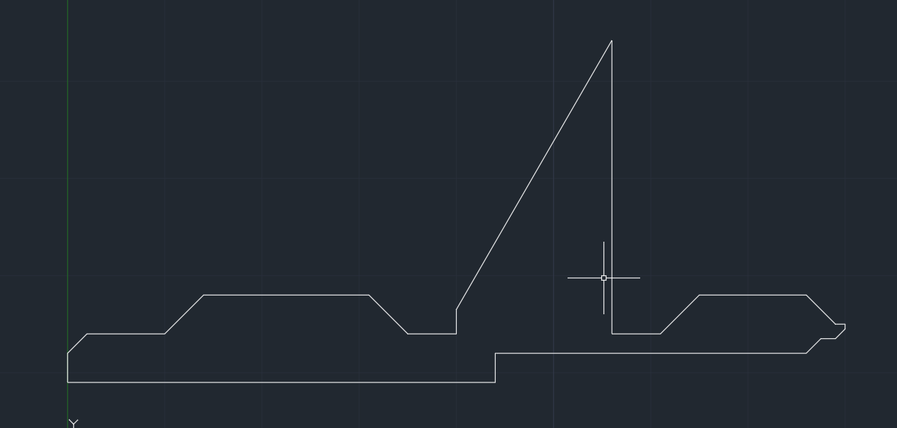

Command: REVOLVE

Current wire frame density: ISOLINES=4, Closed profiles creation mode = Solid

1 found

Specify axis start point or define axis by [Object/X/Y/Z] <Object>: X

Specify angle of revolution or [STart angle/Reverse/EXpression] <360>:

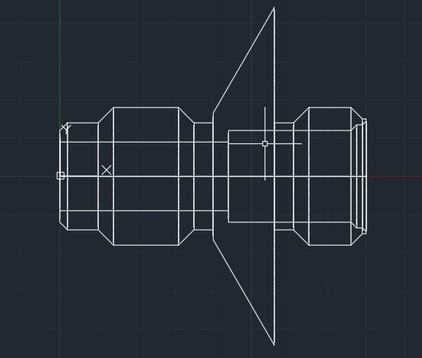

Command: FILLET

Current settings: Mode = TRIM, Radius = 0.0000

Select first object or [Undo/Polyline/Radius/Trim/Multiple]:

Enter fillet radius or [Expression]: 0.5

Select an edge or [Chain/Loop/Radius]:

1 edge(s) selected for fillet.

Command: FILLET

Current settings: Mode = TRIM, Radius = 0.5000

Select first object or [Undo/Polyline/Radius/Trim/Multiple]:

Enter fillet radius or [Expression] <0.5000>: 1.5

Select an edge or [Chain/Loop/Radius]:

1 edge(s) selected for fillet.

Command: FILLET

Current settings: Mode = TRIM, Radius = 1.5000

Select first object or [Undo/Polyline/Radius/Trim/Multiple]:

Enter fillet radius or [Expression] <1.5000>:

Select an edge or [Chain/Loop/Radius]:

1 edge(s) selected for fillet.

Command: FILLET

Current settings: Mode = TRIM, Radius = 0.5000

Select first object or [Undo/Polyline/Radius/Trim/Multiple]:

Enter fillet radius or [Expression] <0.5000>:

Select an edge or [Chain/Loop/Radius]:

1 edge(s) selected for fillet.

Command: FILLET

Current settings: Mode = TRIM, Radius = 0.5000

Select first object or [Undo/Polyline/Radius/Trim/Multiple]:

Enter fillet radius or [Expression] <0.5000>:

Select an edge or [Chain/Loop/Radius]:

1 edge(s) selected for fillet.

Command: ROTATE3D

Current positive angle: ANGDIR=counterclockwise ANGBASE=0

Select objects: 1 found

Select objects:

Specify first point on axis or define axis by

[Object/Last/View/Xaxis/Yaxis/Zaxis/2points]: Y

Specify a point on the Y axis <0,0,0>:

Specify rotation angle or [Reference]: 90

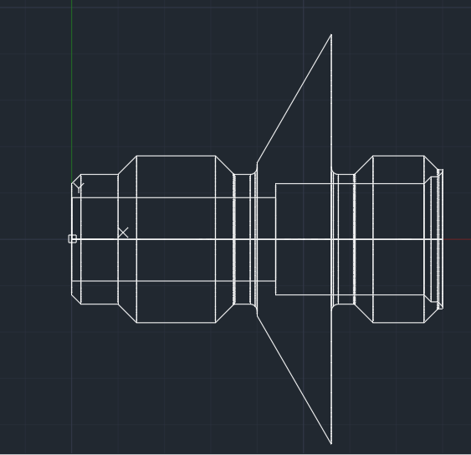

Command: POLYGON

Enter number of sides <4>: 6

Specify center of polygon or [Edge]: 0,0

Enter an option [Inscribed in circle/Circumscribed about circle] <I>: C

Specify radius of circle: 20.5

Command: EXTRUDE

Current wire frame density: ISOLINES=4, Closed profiles creation mode = Solid

Select objects to extrude or [MOde]: 1 found

Select objects to extrude or [MOde]:

Specify height of extrusion or [Direction/Path/Taper angle/Expression] <80.0000>: -80

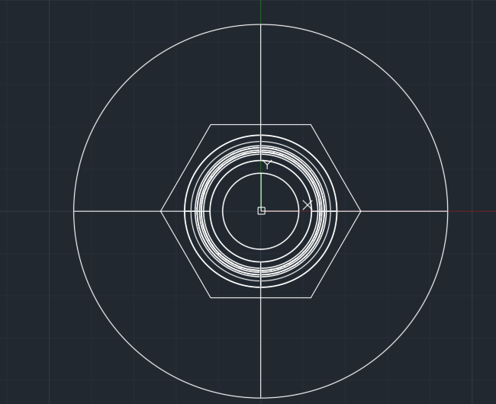

Command: INTERSECT

Select objects: 1 found

Select objects: 1 found, 2 total

Select objects:

